Water Day: media pack
3rd November, Barcelona UNFCCC meeting

- Background information on Water Day
- Water Day Press Release
- Story ideas on water and climate change
- Facts and stats
- Policy and Issue Experts available for interviews

For all media enquiries and interview requests please contact:

Emily Benson ebenson@stakeholderforum.org

Mobile: + 44 (0) 7771 915 591

Lovisa Selander lovisa.selander@siwi.org

Mobile: + 46 (0) 739143986 / +46 (0)706043482

Rosie Bilton rbilton@stakeholderforum.org

Mobile: + 44 (0) 7906 841 215

1. Water Day

Welcome to ’Water Day’ being held on 3rd November alongside the Climate Change negotiations in Barcelona. The day is being convened the Global Public Policy Network on Water (GPPN) (http://gppn.stakeholderforum.org) - a partnership of Stakeholder Forum (www.stakeholderforum.org) and Stockholm International Water Institute (www.siwi.org) – in collaboration with UN Water (www.unwater.org).

The day will show that water is a critical and cross-cutting concern for climate change adaptation and mitigation and that the management of water is fundamental to a range of issues, from alleviating poverty to ensuring energy security and maintaing healthy ecosystems. There will be six sessions which will focus on climate change and a range of water-related issues: Water and Livelihoods; Water, Ecosystems and Forests; Water and Land; Water and Regional/transboundary cooperation; Water and Gender; Water and Energy.

The sessions will bring together water experts and advocates from across the governmental, non-governmental and intergovernmental spheres – including UN Water, the Global Water Partnership, WWF, IUCN, Food and Agriculture Organisation (FAO) and the Freshwater Action Network (FAN) and many more.

The day seeks to build further support for a Copenhagen outcome that clearly recognises the importance of water for tackling climate change, and includes strong and action-orientated text to this end. The day will also stimulate discussion on the post-Copenhagen international policy agenda on water and climate change.

Lunch will be provided at 12.15 pm.

Venue: Fira Congress Hotel
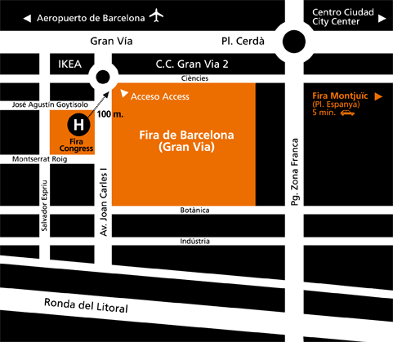

2.PRESS RELEASE: TUESDAY 3rd November 2009

Water evaporates from the climate change negotiating text
Governments, UN agencies, international NGOs and civil society advocates gathered at a Water Day in Barcelona today, to urge negotiators to consider the critical role that water plays in climate change adaptation. The failure to recognise that role risks undermining the wider objective of the negotiations.
Participants called for recognition that water is not a sector but is the primary medium through which climate changes will impact on human populations, society and ecosystems, due to predicted changes in its quality and quantity. The way that water is managed in and between countries will be a critical component for the success of any efforts to adapt to the impacts of climate change. It will also be a vital consideration for many mitigation activities, including hydropower, agriculture and forestry projects.
To a large extent, the global climate crisis is a global water crisis. Yet the latest iteration of the negotiating text on adaptation, the so-called Non-Paper 31, has deleted any clear references to water and its management as a vital consideration for climate change adaptation. This is despite increasing mobilisation by the water community to call for a strong outcome on water from Copenhagen.
"Let me be very clear. There is no development without water. There is no food security without water. There is most likely also no energy security without water. Water is the primary medium through which climate change influences the Earth's ecosystems and therefore people’s livelihoods and well-being. If water is not further recognized in adaptation strategies and plans, we are making a big mistake." Pasquale Steduto, Chair, UN-Water and Service Chief, FAO

“Even with the best mitigation strategies, water related effects of climate change will come. The challenge for many nations is, how to adapt.
Climate Change is in effect Water Change, since it will be through water that the changes will be realized first and foremost.”
Anders Berntell, Executive Director, SIWI
Participants at the Water Day drew particular attention to the following issues:

Climate change impacts on water resources will affect livelihoods and development
90 percent of the 3 billion people who are expected to be added to the population by 2050 will be in developing countries, many in regions already under water stress conditions. Integrated land and water management arrangements will be critical to manage water flexibly among competing users, prioritising human needs.

Climate Change adaptation is not just a national issue
More than 75 percent of the world’s nations have shared river basins within their boundaries. Regional co-operation on climate change adaptation will be vital for addressing climate change impacts on shared water resources, even as a way to prevent potential conflicts.

Investing in ecosystems can help preserve water supplies
Ecosystems build resilience to climate change. Healthy ecosystems need water and in turn help maintain a healthy water cycle. Care must be taken that climate change mitigation activities do not damage and degrade ecosystems, and that adaptation efforts prioritise their preservation. This is critical not least to food security.

Data, information and governance are key
Understanding climate change impacts on water resources will require enhanced data collection and sharing, and increased capacity for gathering and using data. However, climate change impacts are being felt now and improving water governance arrangements to respond to uncertainty and variability will be the key to good adaptation.

Climate change mitigation efforts must take water into account
The projected increase in hydropower and bio-energy to meet low-carbon energy needs will depend heavily on sustained water flows and water availability. Projected changes in the water cycle as a result of climate change must therefore be taken into account. Building dams for water storage and energy needs must be done in the context of understanding and mitigating potentially negative impacts on human populations and the environment. Bio-energy must be balanced with food security and ecosystem protection.
The Water Day was held against a backdrop of drought and famine as many developing countries begin to experience the devastating impacts of climate change on the water cycle. If precautions are not taken, this may lead to an increase in conflicts related to water availability and distribution. Extreme weather events leading to drought and floods, as recently witnessed in Kenya and the Philippines, are predicted to increase in frequency and intensity as a result of climate change, and are likely to become ‘the norm’ in coming decades. It is imperative for the Parties to the UNFCCC to recognize the pivotal role of water in adapting to climate change in order to increase resilience and achieve sustainable development.

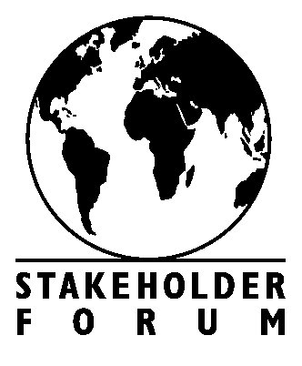

Endorsements:

3. Story Ideas on Water and Climate Change

Politics

Where is water on the global climate agenda?
Water is the primary medium through which climate changes will impact on human populations, society and ecosystems, due to predicted changes in its quality and quantity. The way that water is managed in and between countries will be a critical component for the success of any efforts to adapt to the impacts of climate change. It will also be a vital consideration for many mitigation activities, including hydropower, agriculture and forestry projects.
Yet, the latest iteration of the negotiating text on adaptation, the so-called Non-Paper 31, has deleted any clear references to water and its management as a vital consideration for climate change adaptation. Now, many organizations and experts are advocating that water needs to figure prominently in climate change discussions and negotiations, and needs to be part of any agreement in the UN’s upcoming COP 15 conference in Copenhagen in December 2009. Otherwise the world is unlikely to achieve most of the UN Millennium Development Goals for health, hunger, energy, sanitation, and social progress.
The UN’s own Intergovernmental Panel on Climate Change (IPCC) has concluded that water resources have not been adequately addressed in climate policy formulations. The limited reference to water as a cross-sectoral tool for adaptation in the outcomes of the United Nations Framework Convention on Climate Change (UNFCCC) Conference of the Parties (COP) negotiating process validates the IPCC’s point.
How should we move ahead to get water on the global climate agenda?

How can we move beyond competition for transboundary waters?
Transboundary lake and river basins account for an estimated 60 percent of global freshwater flow and are home to 40 percent of the world´s population. Close to 60 percent of the world’s staple foods are produced in basins shared by two or more countries. Consider another angle on the issue: nearly 96 percent of the world’s accessible freshwater is located in aquifers, many of which cross national boundaries.
As climate change raises the stakes, the issue of transboundary waters presents us with a fundamental question: how can we move beyond competition to manage and develop shared water resources for mutual benefits and opportunities? At present, there is a strong focus on the country-driven approach in the climate change negotiations, when regional cooperation in the transboundary context is likely to be just as important. How can commitments made in Copenhagen help create the pathway for regional cooperation and co-ordination on adaptation?
More than 75 percent of the world’s nations have shared river basins within their boundaries, and 33 nations have more than 95 percent of their territory within such basins. And yet, more than half of the world’s international river basins and transboundary aquifer systems lack any type of cooperative management framework.

The coming wave of climate refugees
As the effects of climate change hit us, some parts of the world will become uninhabitable. Current Intergovernmental Panel on Climate Change (IPCC) projections suggest that rising temperatures and sea levels and increased intensity of droughts and storms will lead to substantial population displacements within the next 30-50 years. Where will these people go? The Maldives, a nation of 300,000 people spread on 1,200 islands located on average 1.5 metres above sea level, is looking into buying a new homeland to insure a place for its citizens to live if their home country sinks under water. Do we have a joint responsibility to deal with the consequences and help those who are worst affected?

Environment and Climate

Melting mountains threaten billions
Between mountain ridges, peaks, and valleys lie the massive glaciers feeding the great rivers of the world. Global warming is increasing faster at higher altitudes, which means ice is melting quicker. Initially, more meltwater can cause flooding. With time, however, glaciers shrink, discharge hits a new equilibrium and water supplies for communities downstream decreases, particularly during the dry season. The glaciers of the Himalayas alone provide water for one-sixth of the world’s population. Are we watching a looming catastrophe?

Rain: The most important climate change
Floods and droughts accounted for 86 percent of the natural disasters that struck nearly two billion people in the last decade of the 20th century. Climate change will make rainfall more variable, meaning more droughts and floods that will present major risks to agricultural production and challenge planners to create proper structures for water storage and conveyance. From ancient rain harvesting techniques to modern cloud seeding technology, managing water supply from the sky is the key to future water supply security.

Climate adaptation: Facing up to a changing world
The effects of climate change are already upon us. A global temperature increase will cause changed run-off patterns, lead to the melting of glaciers, and increase the frequency of droughts, storms, and floods. In parts of the world the hotter climate will lead to an increase in rainfall – posing the risk of more frequent flooding. This is already the case on the eastern seaboard of southern Africa where Mozambique has suffered the effects of massive floods. Another impact of increased temperature is the possibility of greater spreading of water-borne diseases and parasites, such as malaria. Developed and developing, water scarce and water rich nations share different challenges, opportunities and resources. Desmond Tutu, former Anglican Archbishop of Cape Town, warned of climate apartheid: the rich can afford to make temporary adaptations, while poor and vulnerable people are unprotected. How do we, as a society that wants to perpetuate itself, adapt?

Science and innovation

Water storage: mixing ancient know-how with new solutions
From major dams down to buckets, storage is the most immediate approach to safeguarding water resources. As the effects of climate change set in, finding solutions on how to harvest water becomes increasingly important. In the process, ancient methods for rainwater harvesting and groundwater recharge are being rediscovered.

Economy, business and finance

Invest in water, boost an economy
Investments in water and sanitation are still perceived as a cost by many governments. The facts tell a different story: every dollar invested in water supply and sanitation gives back 4 USD - 12 USD back. Good water resources management increases resilience to climate change, leads to social and economic growth and yields economic returns by avoiding costs related to pollution, contamination and disasters.

4. Water and climate change

Facts and stats
- Almost two billion people were affected by natural disasters in the last decade of the 20th century, 86% of them by floods and droughts. (WHO, 2004)
- Flooding increases the ever-present health threat from contamination of drinking-water systems from inadequate sanitation, with industrial waste and by refuse dumps. (WHO, 2004)
- Current IPCC projections of rising temperatures and sea levels and increased intensity of droughts and storms suggest that substantial population displacements will take place within the next 30-50 years, particularly in coastal zones. (3rd UN World Water Development Report, 2009)
- A global temperature increase of 3-4°C could cause floods resulting in 330 million climate refugees. (UNDP: Human Development Report, 2007/2008)
- A global temperature increase of 3-4°C could cause changed run-off patterns and glacial melt will force an additional 1.8 billion people to live in a water scarce environment by 2080. (UNDP: Human Development Report, 2007/2008)
- For the 40 poorest countries, with a total population of some 1–3 billion, climate change may lead them to lose on average up to a fifth of their cereal production potential in the 2080s. (SIWI: Let it Reign: The New Water Paradigm for Global Food Security, 2005)
- An estimated 90% of the 3 billion people who are expected to be added to the population by 2050 will be in developing countries, many in regions already in water stress where the current population does not have sustainable access to safe drinking water and adequate sanitation. (3rd UN World Water Development Report, 2009)
- Adequate investments in water management, infrastructure and services can yield a high economic return by avoiding costs related to water pollution, contamination and disasters. (3rd UN World Water Development Report, 2009)

5. Water Policy and Issue Experts



Mr. Pasquale Steduto, Chair, UN-Water and Service Chief, FAO : Holding a MSc in Water Science and a PhD in Soil-Plant-Water Relationships from the University of California in Davis, Mr Steduto has been working for more than 20 years on agricultural water use efficiency and water productivity, with a focus of crops water requirements, their yield response to water and associate modelling development under water scarcity conditions.

Dr. Ania Grobicki has spent most of her working life on waterrelated issues. She has held positions in the private sector as well as with NGOs and the UN. Dr. Grobicki was a Coordinator for the African National Congress’s Science and Technology Group, a Coordinator for the CGIAR’s Challenge Program for Water and Food, and Head of Secretariat for a multi-stakeholder forum on strengthening research for health, development and equity.



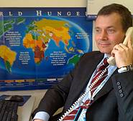

Mr. Anders Berntell, Executive Director, SIWI: has been Executive Director of SIWI since February 2002. A biologist by training, Mr. Berntell is knowledgeable about overall water issues and international development cooperation. He is available to discuss water and infrastructure, law, economics, food, governance, policy and climate issues

Mr. Johan Kuylenstierna, Chief Technical Advisor to the Chair of UN-Water : Johan holds an adjunct professorship in international water issues as the Stockholm University and a PhLic in Climatology and Physical Geography. His expertise is primarily related to water policy issues and water and climate linkages but as a generalist, he can address most water and climate related issue at a non-expert level.

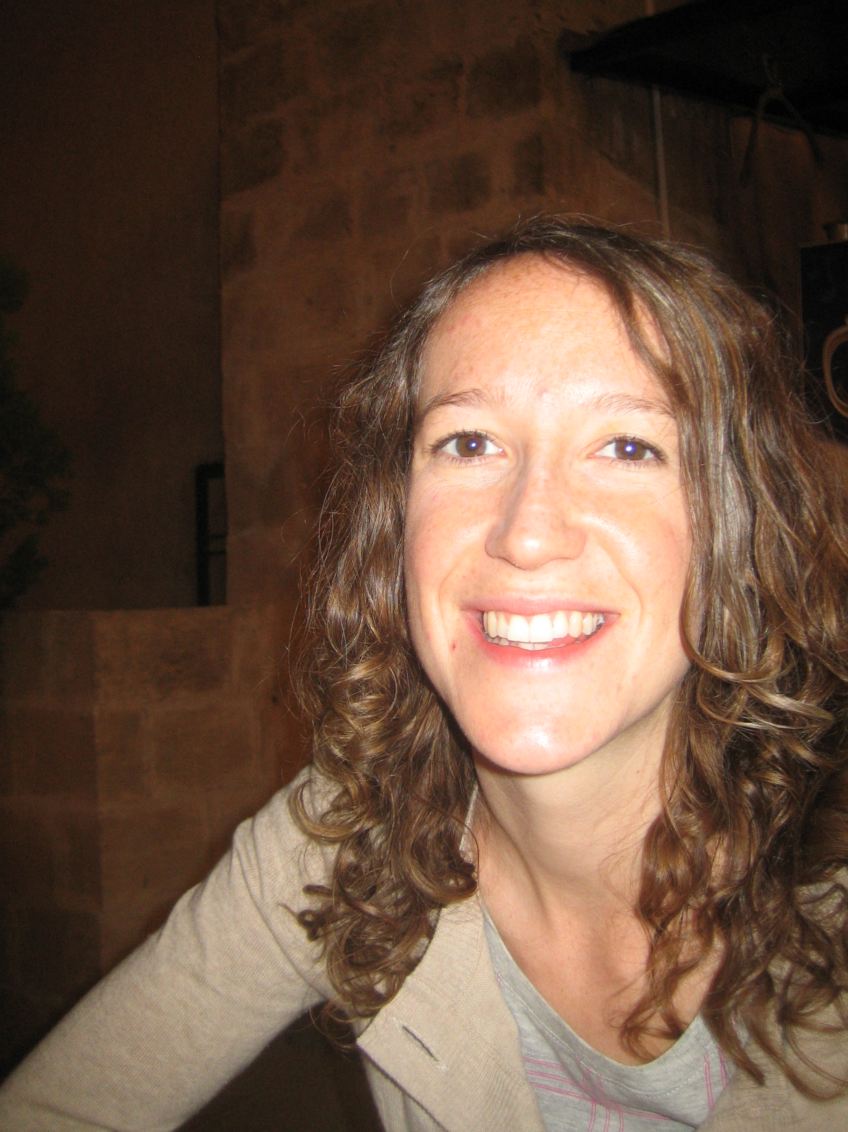

Ms Hannah Stoddart, Policy Co-ordinator, Stakeholder Forum, and GPPN Secretariat: has been working actively on water and climate advocacy at the UNFCCC negotiations for the past year. Her expertise is mainly relating to the status of the climate change negotiations, especially on adaptation and the profile of water. She can also talk fluently on the key policy priorities for water and climate change adaptation in the international context.

